**Question 11: How has the global average life expectancy changed from 1952 to 2007?**

Answer:-

**Analysis:**

The global average life expectancy has shown a significant increase from 1952 to 2007. In 1952, the average life expectancy was around 48 years, whereas in 2007, it had risen to approximately 69 years. This indicates an increase of about 21 years over the span of 55 years.

**Reasons for Increased Life Expectancy:**

1. **Advancements in Medical Technology:**

- Development of vaccines and antibiotics.

- Improved medical treatments and surgeries.

- Reduction in infant mortality rates due to better neonatal care.

2. **Improved Public Health Infrastructure:**

- Increased access to clean water and sanitation.

- Public health campaigns against smoking, alcohol, and unhealthy diets.

- Better healthcare facilities and services.

3. **Economic Development:**

- Higher GDP per capita leading to better living standards.

- Investments in healthcare and education sectors.

- Improved nutrition and food security.

4. **Global Health Initiatives:**

- International organizations like WHO and UNICEF promoting health initiatives.

- Eradication of diseases like smallpox and efforts to control malaria, polio, and HIV/AIDS.

5. **Education and Awareness:**

- Increased awareness about personal health and hygiene.

- Better maternal education leading to healthier children and families.

**Visualization:**

A line graph showing the increase in global average life expectancy from 1952 to 2007:

**Question 12: For the year 2007, analyze the relationship between life expectancy and GDP per capita.**

**Analysis:**

In 2007, there is a noticeable positive correlation between life expectancy and GDP per capita. Countries with higher GDP per capita tend to have higher life expectancy. This correlation suggests that wealthier countries can invest more in healthcare, nutrition, and overall quality of life, which contributes to longer life expectancy.

**Scatter Plot:**

The scatter plot below illustrates the relationship between life expectancy and GDP per capita for various countries in 2007:

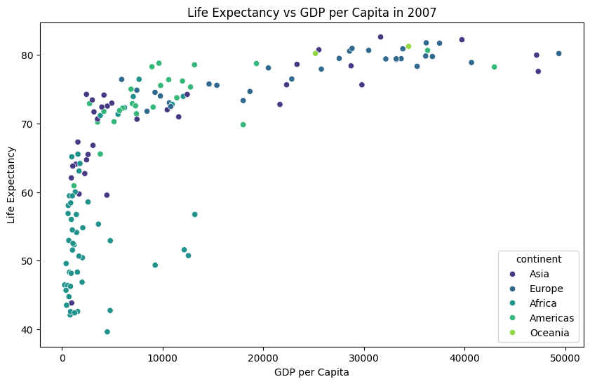

**Conclusion:**

Countries with higher GDP per capita generally have better healthcare systems, higher standards of living, and better overall health outcomes, leading to higher life expectancy.

**Question 13: Compare the average GDP per capita for each continent in the year 2007.**

**Analysis:**

In 2007, the average GDP per capita varied significantly across continents. Oceania had the highest average GDP per capita, followed by Europe, the Americas, Asia, and Africa.

**Bar Chart:**

The bar chart below compares the average GDP per capita for each continent in 2007:

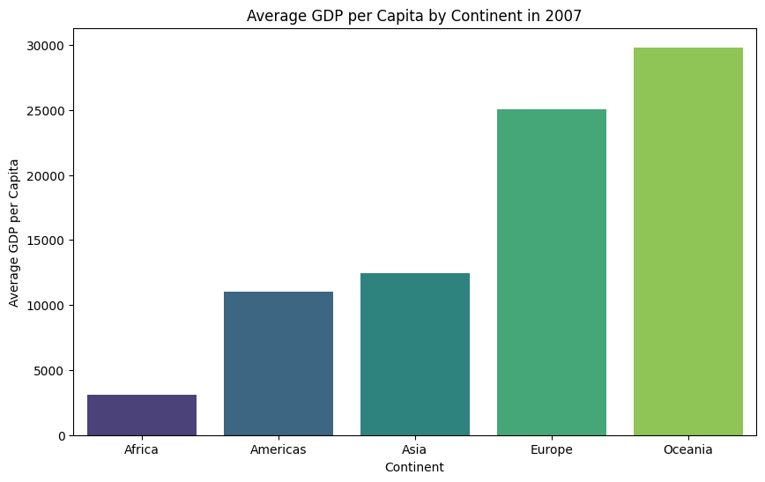

**Reasons for Higher GDP per Capita in Oceania:**

1. **Country Composition:**

- Oceania includes highly developed countries like Australia and New Zealand with high GDP per capita.

- The Americas have a wider range of economic development levels, including both wealthy countries like the United States and poorer countries.

2. **Economic Distribution:**

- Wealth in Oceania is concentrated in a few high-income countries.

- The Americas have a more diverse economic landscape with significant disparities.

3. **Population and GDP:**

- Oceania's population is smaller but has a high GDP output.

- The Americas have a larger population with varied economic output across countries.

**Question 14: Compare the life expectancy and GDP per capita of Afghanistan and Switzerland in 2007.**

**Analysis:**

In 2007, Afghanistan had a significantly lower life expectancy and GDP per capita compared to Switzerland. This stark contrast highlights the impact of stability, economic development, and access to healthcare on these key metrics.

**Bar Chart for 2007:**

The bar chart below directly compares the life expectancy and GDP per capita between Afghanistan and Switzerland in 2007:

**Line Graphs for Trends:**

The line graphs below show the trends of life expectancy and GDP per capita over the years for Afghanistan and Switzerland:

**Conclusion:**

**-** **Life Expectancy:**

- Switzerland's life expectancy is significantly higher than Afghanistan's.

- Switzerland benefits from stability, economic prosperity, and advanced healthcare.

- Afghanistan's lower life expectancy is due to conflict, economic challenges, and limited access to healthcare.

**-GDP per Capita:**

- Switzerland's GDP per capita is much higher than Afghanistan's.

- Switzerland has a strong and stable economy, contributing to better living standards.

- Afghanistan's GDP per capita is low due to prolonged conflict and instability.

**Impact of Stability on Metrics:**

- Stability and economic prosperity lead to better healthcare, education, and living conditions.

- Countries with political stability and strong economies tend to have higher life expectancy and GDP per capita.

- Conflict and instability negatively impact health outcomes and economic development, as seen in Afghanistan.